SENDGRID INTEGRATE WITH PYTHON

|  |  |
| --- | --- |
| DATE: | 4 NOV 2022 |
| TEAM ID: | PNT2022TMID43156 |
| PROJECT NAME: | NUTRITION ASSISTANT APPLICATION |

STEP 01:

Requirements- python 2.5,2.7,3.5,3.7 or 3.10.7

STEP 02:

Create an API key

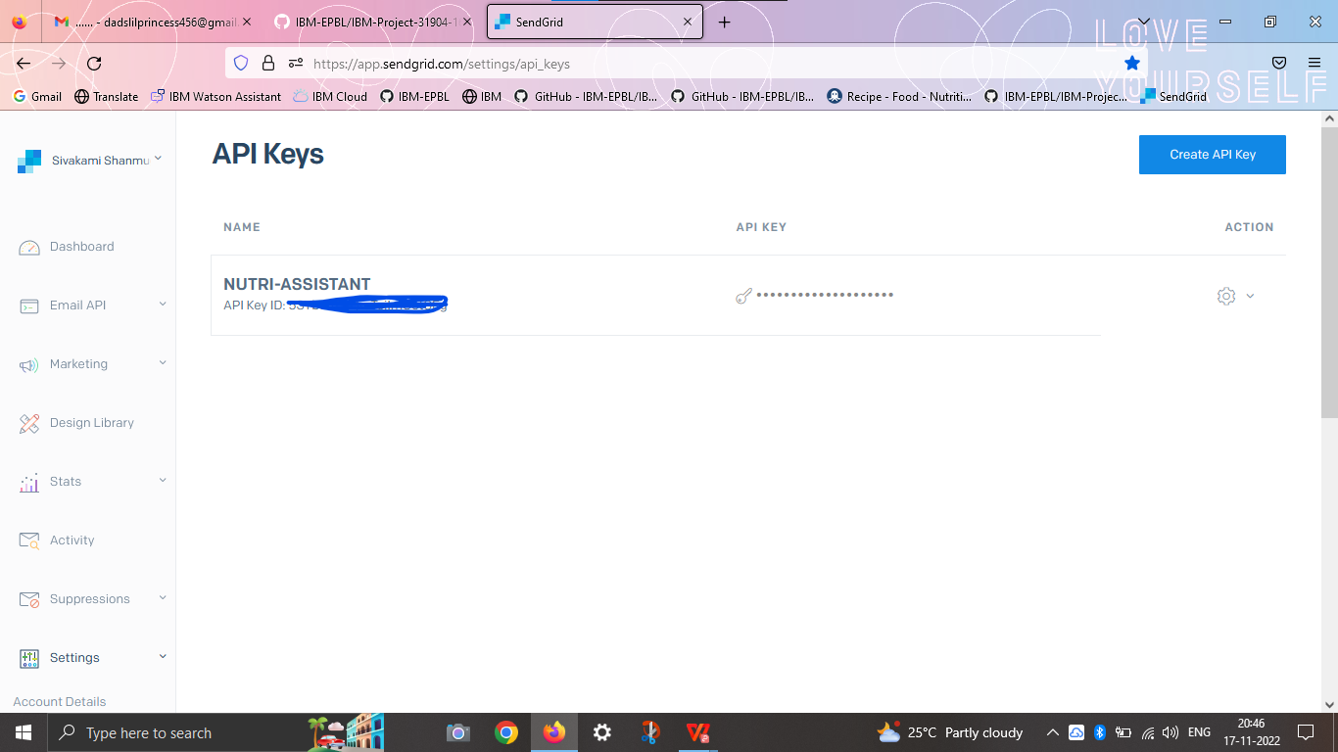

STEP 03:

INSTALL PACKAGE- >pip install send-grid

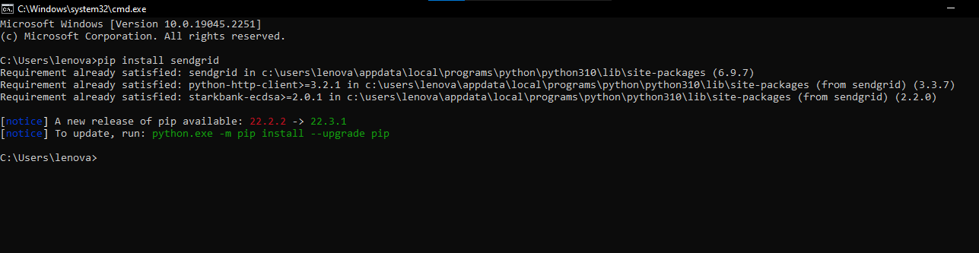

STEP 04:

SEND MAIL

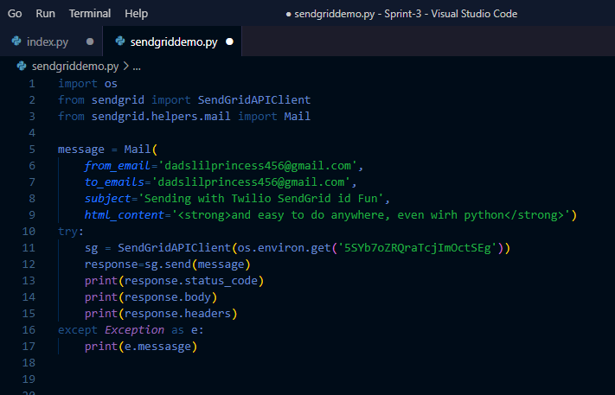

STEP 05:

INTEGRATE WITH PYTHON

